Dawson boys BASKETBALL CAMP
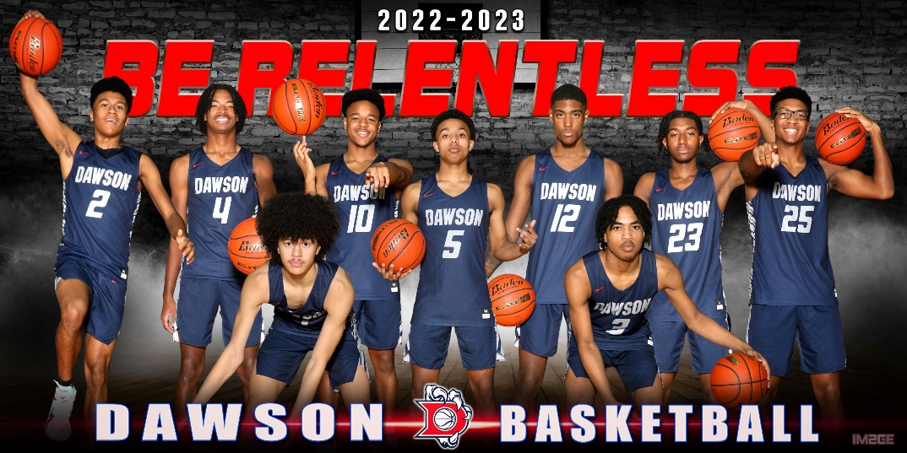
23-6a District Champs, Bi-District Champs, Area Champs, & Regional Quarterfinalists

JUNE 12TH – 15TH (MON – THURS)

AGES 5 – 9th GRADE INVITED

LOCATION:
Dawson High School Gym
2050 Cullen Blvd.
Pearland, TX 77581
9th Grade Camp: 1pm- 4pm
All Incoming Freshmen
Cost: By June 10th -- $110
AFTER June 10th (incl walk-ups) -- $130
All incoming freshmen will attend camp at Berry Miller Jr. High. Where the campers will participate in more advanced drills and competitions and learn more team concepts.
Session 2: 1pm – 4pm
Grades 5th – 8th
Cost: By June 10th -- $110
AFTER June 10th (incl walk-ups) -- $130
Fundamentals of the game are still stressed for the older campers. Drills will be more advanced & campers will have the opportunity to participate in contests, competitions, & games

Session 1: 9am - Noon
Ages 5 – 4th Grade
Cost: By June 10th -- $110
AFTER June 10th (incl walk-ups) -- $130
Young players will learn fundamentals of the game. Campers are separated by age & ability in order to learn dribbling, passing, shooting & defense. They will also participate in contests and games during the week.
Contact Information

For questions or more info contact:
Jordan Rose
409-739-4598
Rosej@pearlandisd.org

Coaching Staff
Dawson Coaches:
Mark Barre, Jordan Rose, & Connor Cox

Professional Players
Collegiate Players
Former Dawson Players

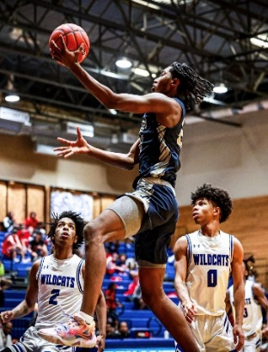
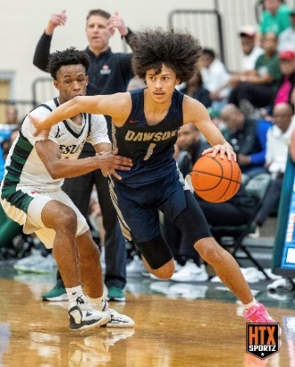
DETACH THIS FORM & SUBMIT
ALONG WITH YOUR PAYMENT

Name: _______________________________________ Age: Grade (Fall 2022):

Address: ________________________________________ City: Zip:___________

Parent Name: E-Mail: _______________________________________

Contact Phone #: ________________________

Insurance Release Form: Applications will not be accepted without completion of this insurance information!
I, the undersigned, as the parent or legal guardian of the minor child, __________________________, hereby acknowledge that the above named child is covered by medical insurance as follows: Insurance Company:_______________________
Policy Holder: ____________________________

I, as parent or guardian, hereby give permission for my child to participate in the Dawson Boys Basketball camp and acknowledge the fact that he/she is physically able to participate in camp activities. I hereby authorize the camp staff to act for me according to their best judgment in any emergency requiring medical attention. I acknowledge that I may be responsible for any cost (through family medical insurance or otherwise) incurred due to sickness or injury to my son/daughter. I hereby waive any claim I might have against the camp, director, or the institutions providing the facilities.

“This athletic camp/clinic follows guidelines set forth by Pearland ISD and the UIL.”

Parent Signature:_______________________________ Date:__________ Amount Enclosed: $__________

Registration Form & Info on Back of Flyer

Which Session will your child be attending? (Circle One Below)
Session 1 (Age 5 – 4th Grade) $110
Session 2 (5th – 8th Grade) $110
9th Grade Camp - $110

Please include your child’s shirt size.

T-Shirt Size (Circle One)
Youth - YS YM YL YXL
Adult – S M L XL

**Preferred registration method**
Payment Methods:

Zelle
barrem@pearlandisd.org

MAKE CHECKS PAYABLE TO:
Dawson Boys Basketball Camp

*Cash will also be accepted*




Or
Mail Registration & Fee To:
Dawson Boys Basketball c/o Mark Barre
2050 Cullen Blvd
Pearland, TX 77581

